

**DEPARTMENT OF INFORMATION & COMMUNICATION TECHNOLOGY**

**LAB EXERCISE 3 | SESSION 1 2024/2025SHORT SEM MEI 2021**

**DFP40203 – PYTHON PROGRAMMING**

**DURATION : 2 HOURS**

|  |
| --- |
| **CLO1:** Construct Python application based on a given scenario (P4, PLO3) **INSTRUCTIONS:**  Answer ALL the questions. Students are asked to discuss and upload the findings of the discussion in CIDOS. Discussions should be done in groups of 2 persons. Students will be assessed according to the Rubric included along with the questions. |

**QUESTION:**

**Scenario:** You are working as a software developer for a university's administration system. You’ve been tasked with handling student data stored in files and organizing directories based on course registrations. The tasks also involve ensuring that your programs are robust and can handle errors appropriately. [CLO1, P3]

1. The university administration requires you to store student details in a text file. Your task is as follows:
   1. Create a text file named student_record.txt. With list of minimum 3 students.
   2. Write the following information to the file:

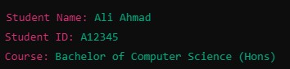

* 1. Read and display the content of the file.

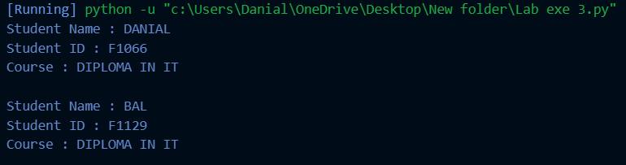

* 1. Append the current date and time when the student information was added.

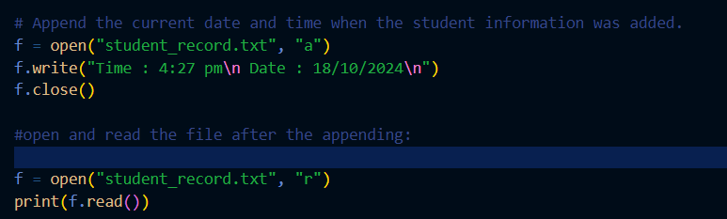

1. The administration stores files for different departments in a directory. Your task is to list all files and subdirectories in the university_data directory. Display whether each item is a file or a directory.

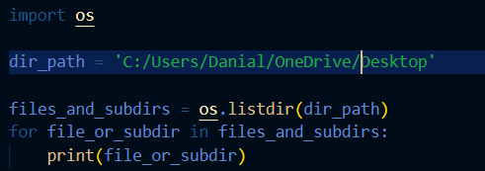

1. The university needs to organize student files by moving them into a new directory. Complete the following tasks:
   1. Create a new directory called student_files.

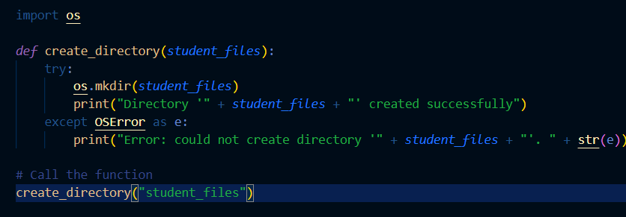

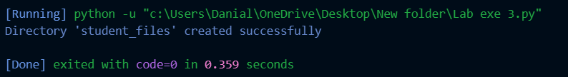

* 1. Move student_record.txt into student_files.

* 1. Rename the file to student_info.txt inside the student_files directory.

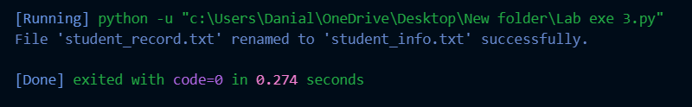

* 1. After confirming that the file has been moved and renamed, delete the file and the directory.

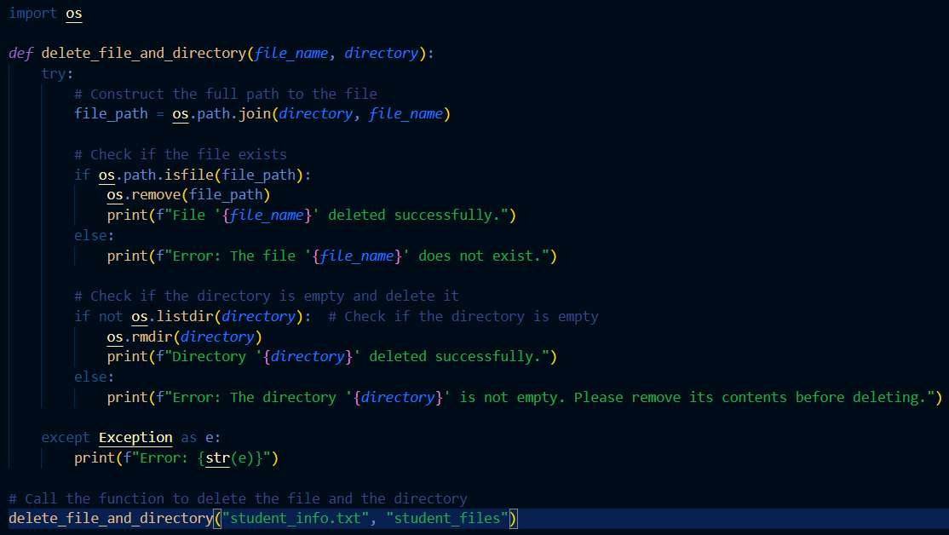

1. The system should handle potential errors to avoid crashing. Complete the following tasks:

**Part A: Handling Exceptions:** Modify the file handling code from **Exercise 1** to manage the following exceptions:

o FileNotFoundError

o IOError

**Part B: Raising Exceptions:** Write a function that checks if a student is eligible for enrollment based on age. If the student's age is below 18, raise a ValueError.

**SCORING RUBRIC LAB EXERCISE 3**

|  |  |
| --- | --- |
| STUDENT NAME | REGISTRATION NO |
| MUHAMMAD IQBAL MIERZA | 10DDT22F1129 |
| MUHAMMAD DANIAL SYAHMI | 10DDT22F1066 |
|  |  |

|  |  |  |  |  |  |  |
| --- | --- | --- | --- | --- | --- | --- |
| **NO** | **CRITERIA** | **4** | **3** | **2** | **1** | **SCORE** |
| 1 | Mastery of Functions | Exhibits advanced mastery in the use of functions,  flawlessly implementing default parameters, recursion, lambda functions, and understanding scope. | Competently defines, uses, and understands functions, including the use of default parameters, variable scope, and recursion, with minor mistakes. | Can define and call functions but  has difficulty with more advanced concepts such as  default parameters, variable scope, or recursion. | Demonstrates limited understanding of function syntax; struggles with defining and calling functions. |  |
| 2 | Understanding  File and  Directory  Handling  Concepts | Excels in applying File and Directory Handling, creating well- structured, reusable code that correctly implements advanced concepts | Demonstrates a  solid understanding of File and  Directory Handling, with minimal errors. | Understands basic File and  Directory Handling concepts but struggles to  correctly implement in Python. | Shows little understanding of File and Directory Handling concept. |  |
| 3 | Command  Usage | Able to use all  Python  Functions and  File and  Directory Handling commands  correctly with no errors | Able to use  Python  Functions and  File and  Directory Handling commands  correctly with minor errors | Able to use some Python Functions and File and Directory Handling commands but with a major error (difficult to fix errors) | Unable to use  Python  Functions and  File and  Directory Handling commands. |  |
| 4 | Correct Output | Able to display correct output as needed with no errors | Able to display output with minor errors | Able to display certain output but has major errors. | Unable to display any output. |  |
| 5 | Ability to meet the Task  Requirement | The task was completed by meeting all the given criteria. | The task was completed by meeting the  given criteria but needed several minor modifications. | The task was completed by meeting some given criteria but needed several major modifications. | The task was not completed and did not meet any criteria. |  |
|  |  |  |  | **TOTAL MARKS ( /20)** | |  |